How to set up 2N with Josh
Table of contents
Hardware requirements 1
Supported 2N Models 1
2N License Needed for Josh Integration 1
Local vs Remote Configuration 2
Configuration prerequisites 3
Incoming Calling (2N to Josh) 11
1. Add User for Josh system 11
2. Add Josh system user to Button Dialing 12
Features 14
Troubleshooting 14
Other useful settings and related information 16
Door Stations 16
Video Streaming 16
Doorbell Press Announcement 16
Access Control/Relays 17
DoorLink 17
Notifications/Scene Triggers 18

Hardware requirements
For the integration with 2N the DoorLink function is necessary.
DoorLink is the ability to call and answer your 2N Door Station, with real time 2way audio and streaming video. When the Doorbell button is pressed on a Door Station, Touchscreens will indicate an incoming call and mobile phones can receive push notifications. The user can accept or decline the call.
DoorLink is only supported by Josh Core and Josh One systems. Josh Micro systems will only have access to video streaming and no audio call functionality.

Supported 2N Models
- 2N IP Verso, 2N IP Verso 2.0 + modules
- 2N IP Solo
- 2N IP Base
- 2N IP Force
- 2N IP Style
- 2N IP One
- 2N CLIP
Note: Josh also supports 2N door stations sold under Control4 labels

2N License Needed for Josh Integration
To leverage the 2N integration, your clients will need to purchase a 2N Gold License license.
Note for Crestron dealers: Crestron’s integration with 2N is built using Rava SIP (a proprietary Crestron protocol). Josh and other 2N integration partners use their HTTP API, which is a licensed feature. This difference is why Crestron systems DO NOT require paying for a 2N license, while Josh and other control systems need a license in order to support the integration.

Local vs Remote Configuration
2N devices can be configured remotely via My2N or locally via a web browser pointed at the device’s IP address. If your 2N license supports remote configuration, you should see the following service on the My2N page for your Door Station device.

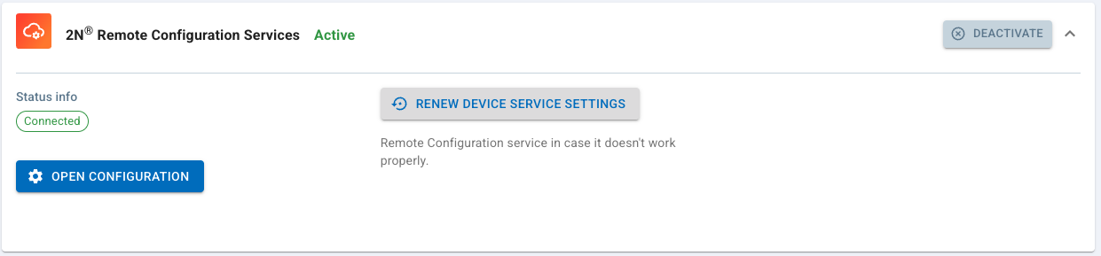
When a 2N device can be remotely configured, there is also a Configuration mode which can be either Automatic or Manual. This is found under Network settings for the device. If it is Automatic, changes made locally may not be saved. For Automatic Configuration mode, we recommend only making configuration changes remotely through My2N.
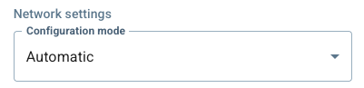

Configuration prerequisites
Note: We recommend firmware version 2.46.0.70.3 or higher. Configuration settings below pertain to the UI in version 2.46.0.70.3

- Navigate to the IP address for each 2N unit in your browser to access 2N Configuration or remotely via My2N.
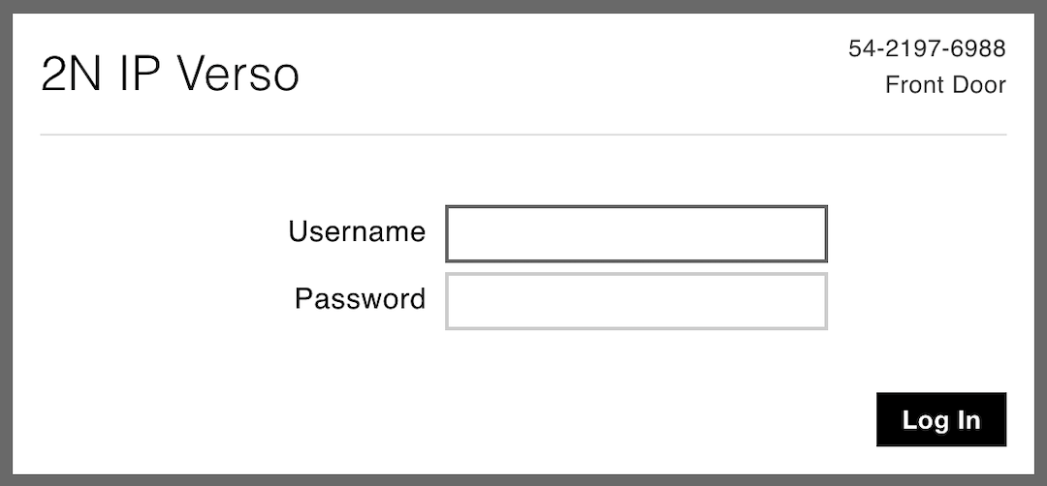
- Navigate to Services > HTTP API > Services and enable the following. We recommend using Secure (TLS) Connection Type and Digest Authentication, though these are not required.
- System API
- Switch API (for relays)
- Camera API (for camera streaming)
- Phone/Call API (for Josh DoorLink Intercom. Note: only supported on selected Josh hardware)
- Logging API
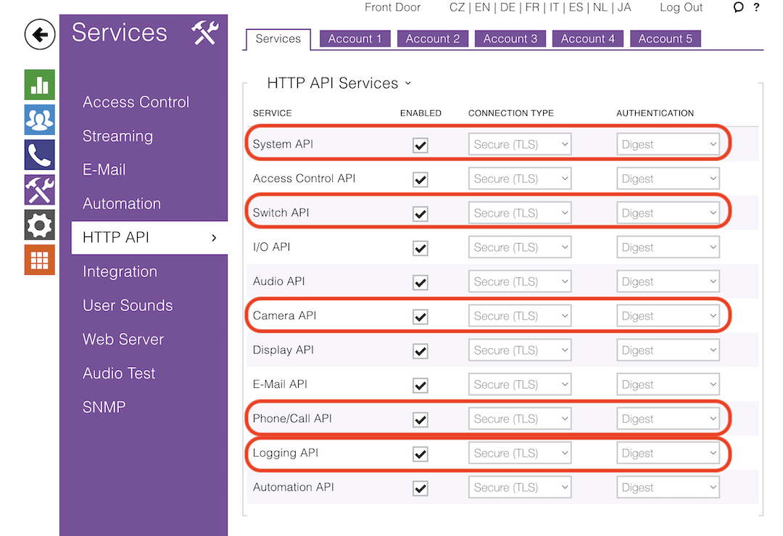
- In Services > HTTP API navigate to one of the Account tabs (e.g. Account 1), click Account Enabled and enter a username/password. Enable the following access for the account:
- System (Monitoring and Control)
- Phone/Calls (Monitoring and Control for Josh DoorLink Intercom. Note: only supported on select Josh hardware)
- Switches (Control for relays)
- Camera (Monitoring for camera streaming)
- Keypad Access (Monitoring for Doorbell button press events)

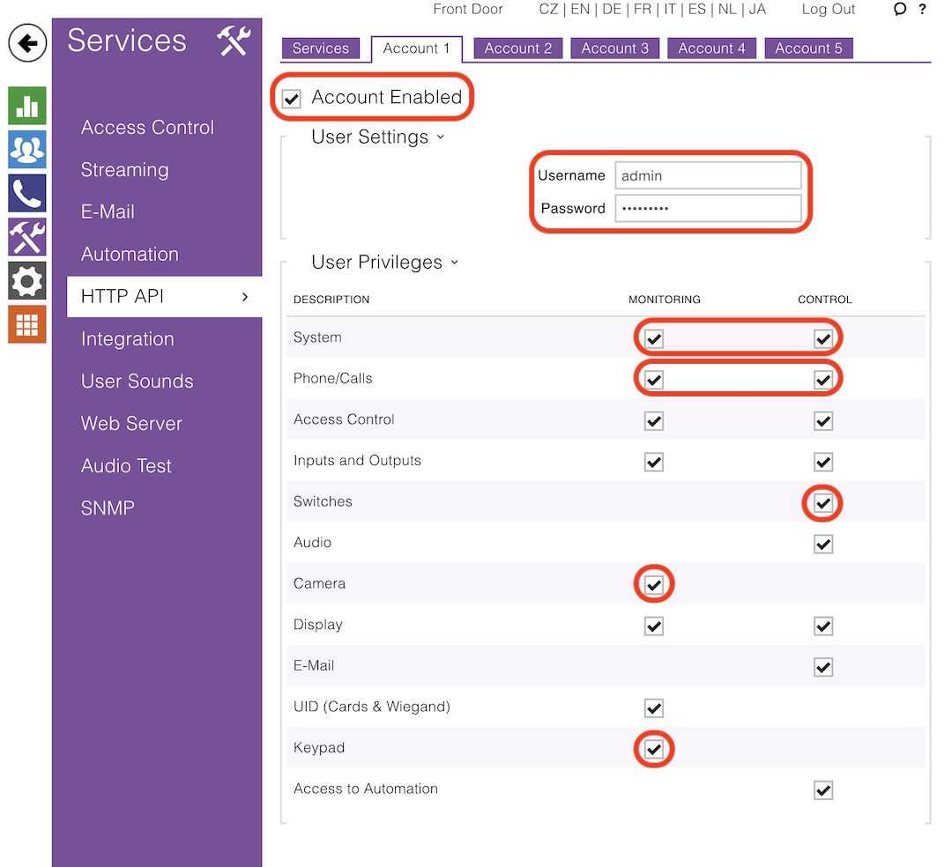

- For camera video streaming, navigate to Services > Streaming.
- Check RTSP Server Enabled
- Under Stream Settings, check Video Stream Enabled
- Under User Accounts, add Name and Password using the same credentials for the HTTP API Account you added for Josh above
- Under Fixed Streaming Profiles, set Default Video Codec to H.264
- Under Fixed Streaming Profiles, you can modify the H.264 Video Parameters. We suggest VGA, 15 fps, 512 kbps.

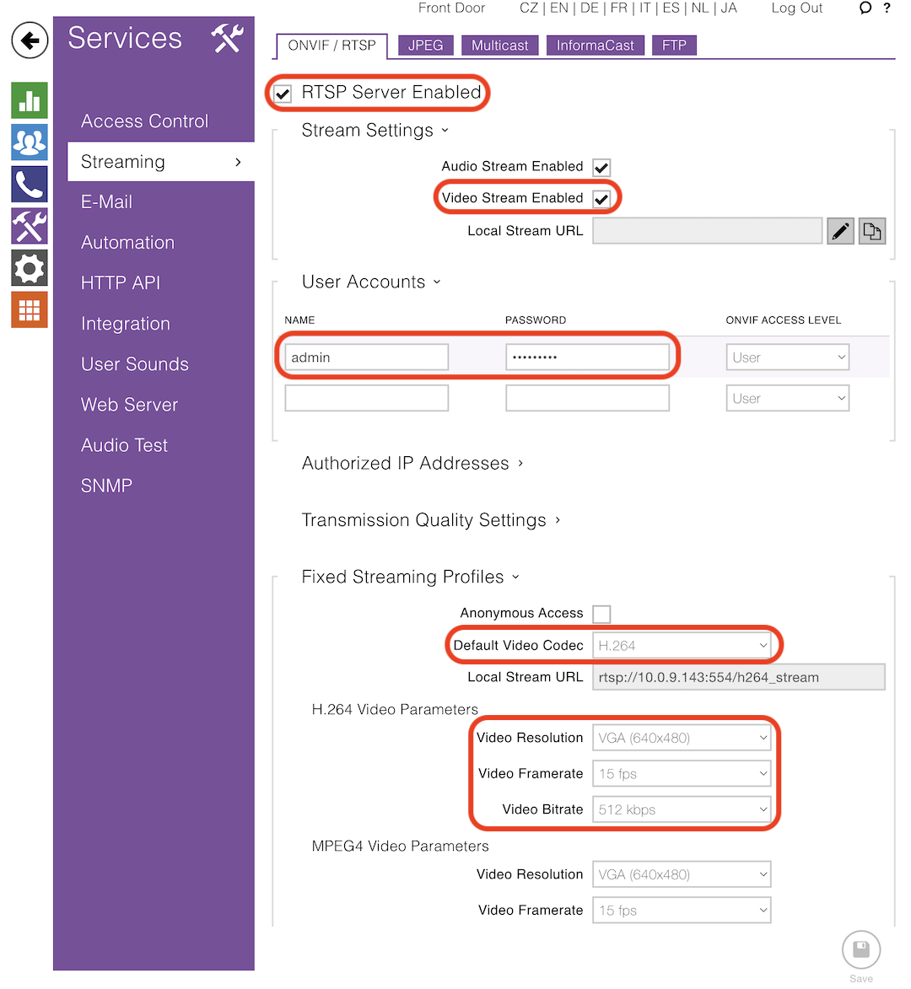

- Navigate to Services > Web Server. Edit the Device Name, which Josh will use for the device name.
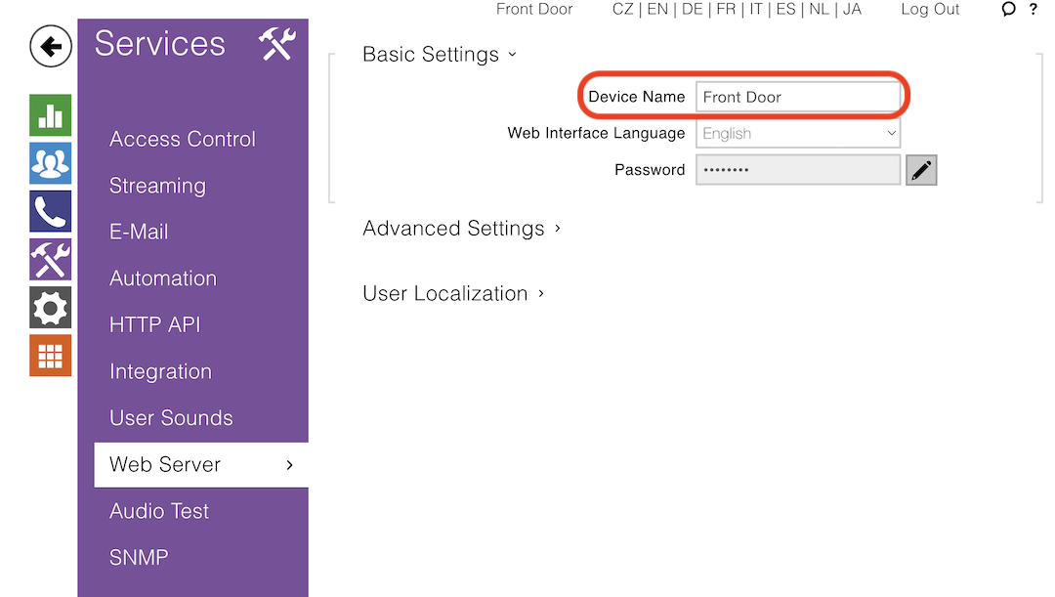
- To enable Josh DoorLink Intercom, navigate to Calling. Note that Josh DoorLink Intercom is only available on select Josh hardware.
- Under General Settings, set the Call Time Limit. We recommend 180s
- Identify the first available SIP profile (i.e. SIP 1, SIP 2, …). Some models will have SIP 1 pre-configured, so move on to SIP 2 etc. until you find an available one. I reference SIP 1 below, but apply the same settings to your SIP profile
- Under General Settings > Incoming Calls, set Call Answering Mode (SIP 1) to Automatic
- Under SIP 1 > Configuration, check SIP Account Enabled
- Under SIP 1 > Configuration > SIP Proxy, set the Proxy Port to 5060
- Under SIP 1 > Configuration > Advanced Settings, set the Local SIP Port to 5060
- Under SIP 1 > Audio, check PCMU Enabled

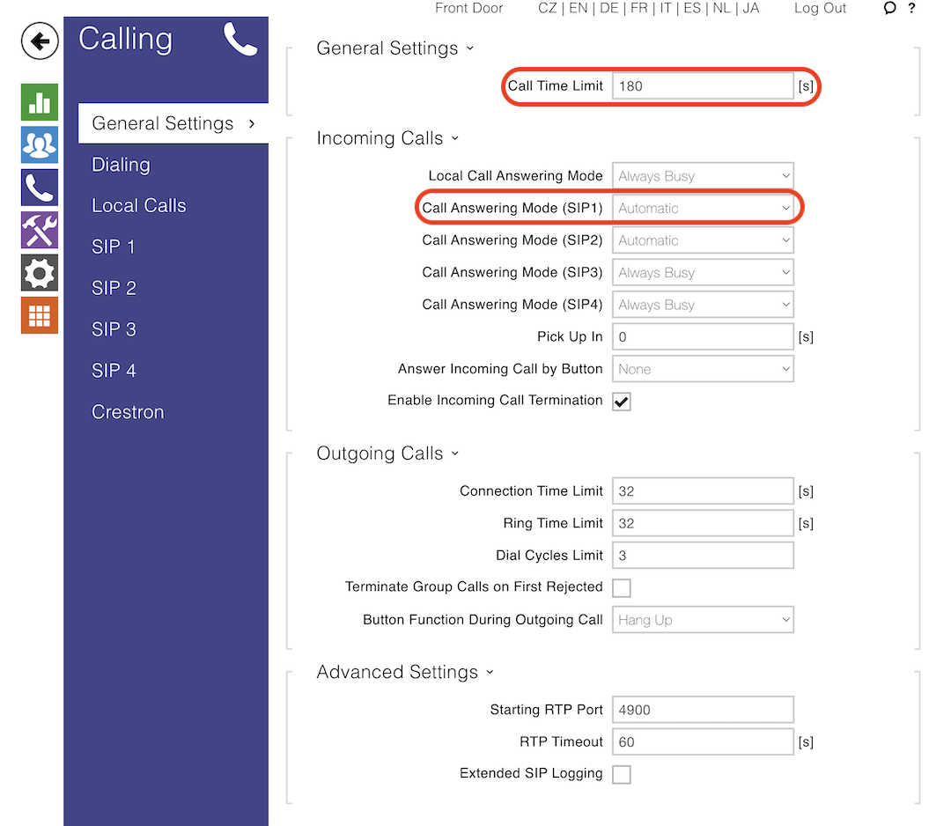
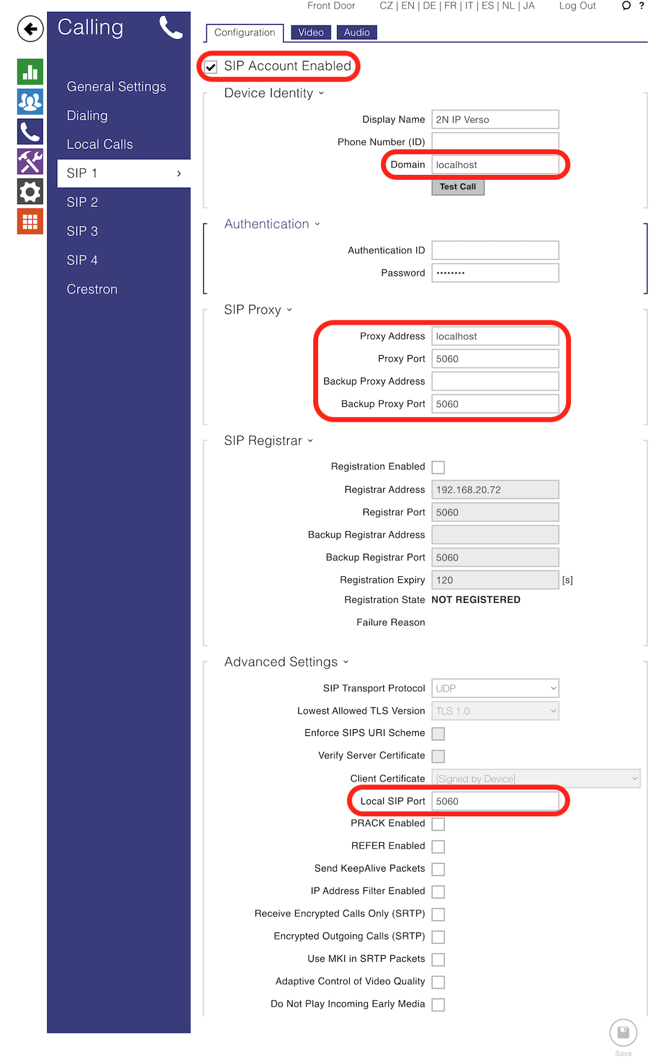
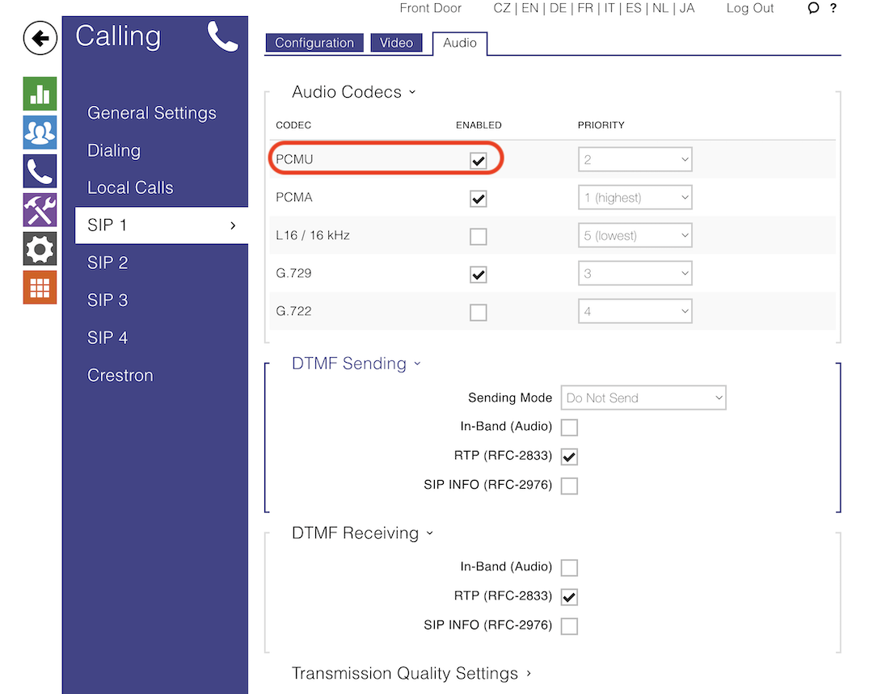

- Authorize at Josh Portal > System Setup > Configure Devices with the HTTP API account created above.

Incoming Calling (2N to Josh)
2N Door Stations can be configured to call mobile phones or other SIP systems when the doorbell button is pressed. When you have this setup, there is additional 2N configuration required to allow Josh to accept incoming calls from 2N.

1. Add User for Josh system
- Navigate to Users and select Add User
- Fill in Name. The exact value doesn’t matter, but this may be displayed on the Door Station during the call
- Fill in Phone Number. This should be of the format sip:10.0.9.141:5060
  - 10.0.9.141 is the IP address of your Josh processor. Note: We recommend adding a DHCP reservation for your Josh processor in your network configuration, so that this can’t change
  - 5060 is the port of the SIP server running on Josh server that is listening for the incoming call
- Click Save
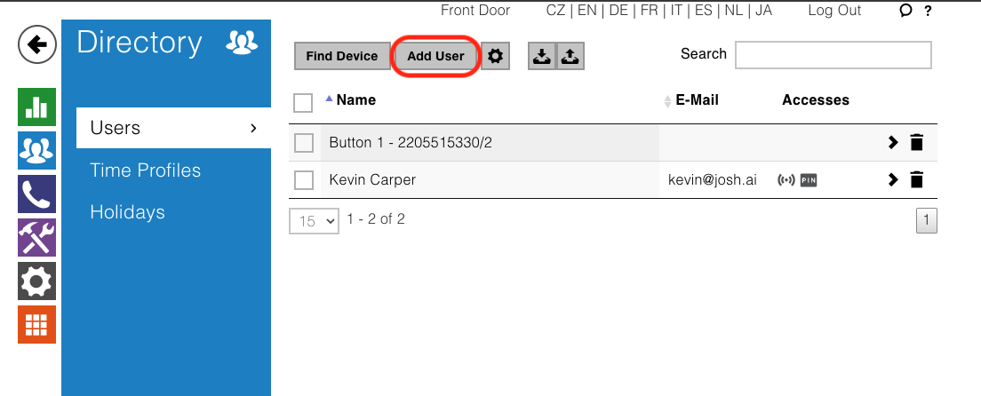
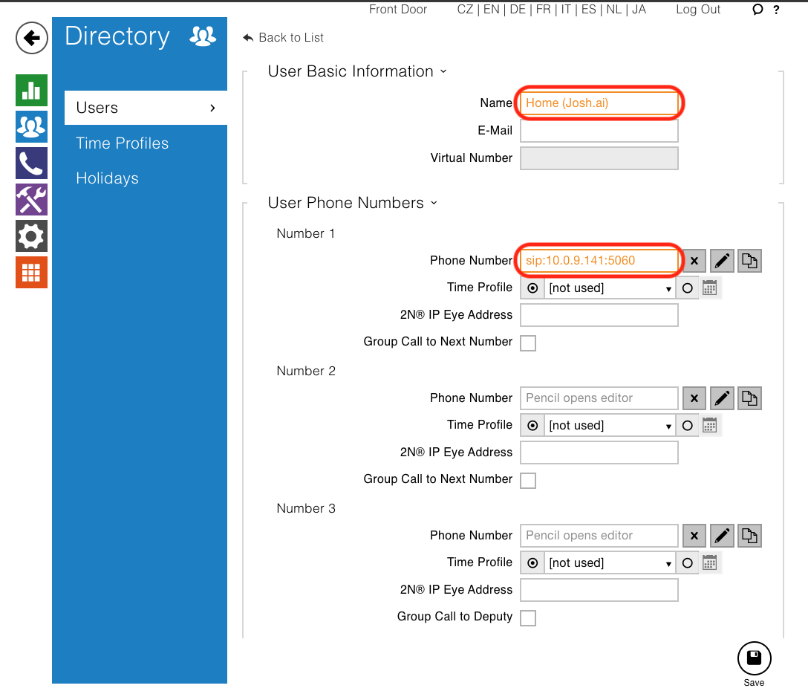

2. Add Josh system user to Button Dialing
- Navigate to Dialing and select the + button
- Select the phonebook entry for the Josh system created above
- Click Add
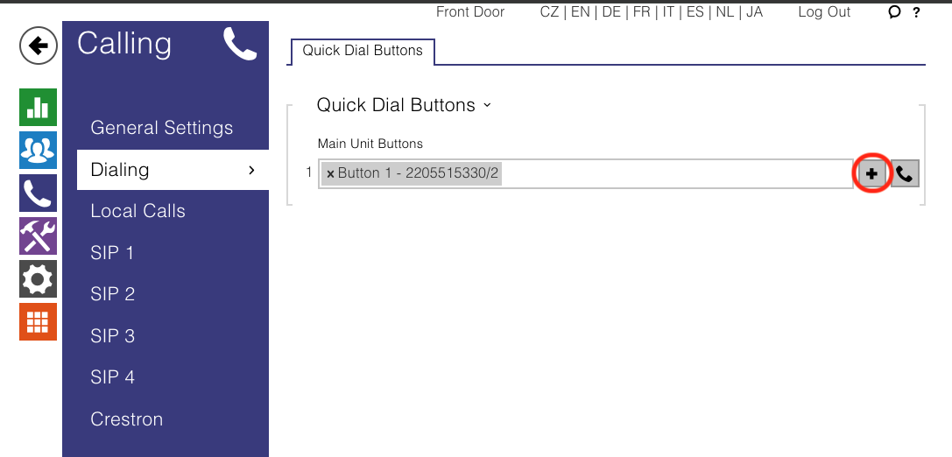
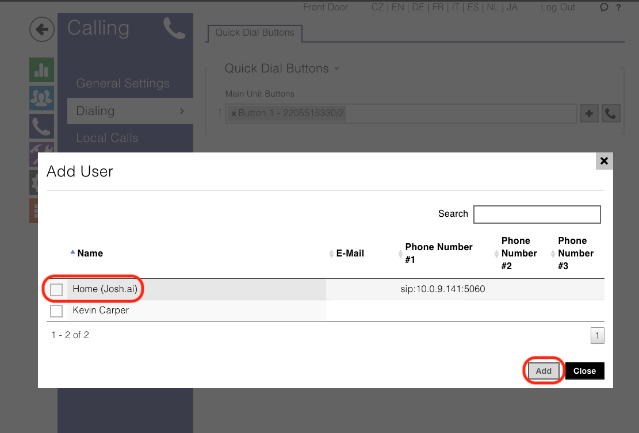

Features
The following features are supported in Josh
- Video streaming
- Doorbell press triggers (not supported on 2N IP Style)
  - Play chime
  - Play custom announcement
  - Play AI analysis of camera
  - Execute scene
- Built-in relay control
- Motion sensing
- Sound sensing
- DoorLink on select Josh Hardware

Troubleshooting
- Video not working: Double check your Services > Streaming settings as described in Configuration Prerequisites above.
- Unable to connect to camera video stream. Please ensure RTSP is enabled on the camera: Double check your Services > Streaming settings as described in Configuration Prerequisites above.
- Unable to start camera video stream. Please ensure H.264 video is enabled on the camera: Double check your Services > Streaming settings as described in Configuration Prerequisites above.
- DoorLink call not working: Double check your Calling settings as described in Configuration Prerequisites above.
- DoorLink call audio is difficult to hear: In the 2N Configuration webpage, navigate to Hardware > Audio. Adjust volumes.

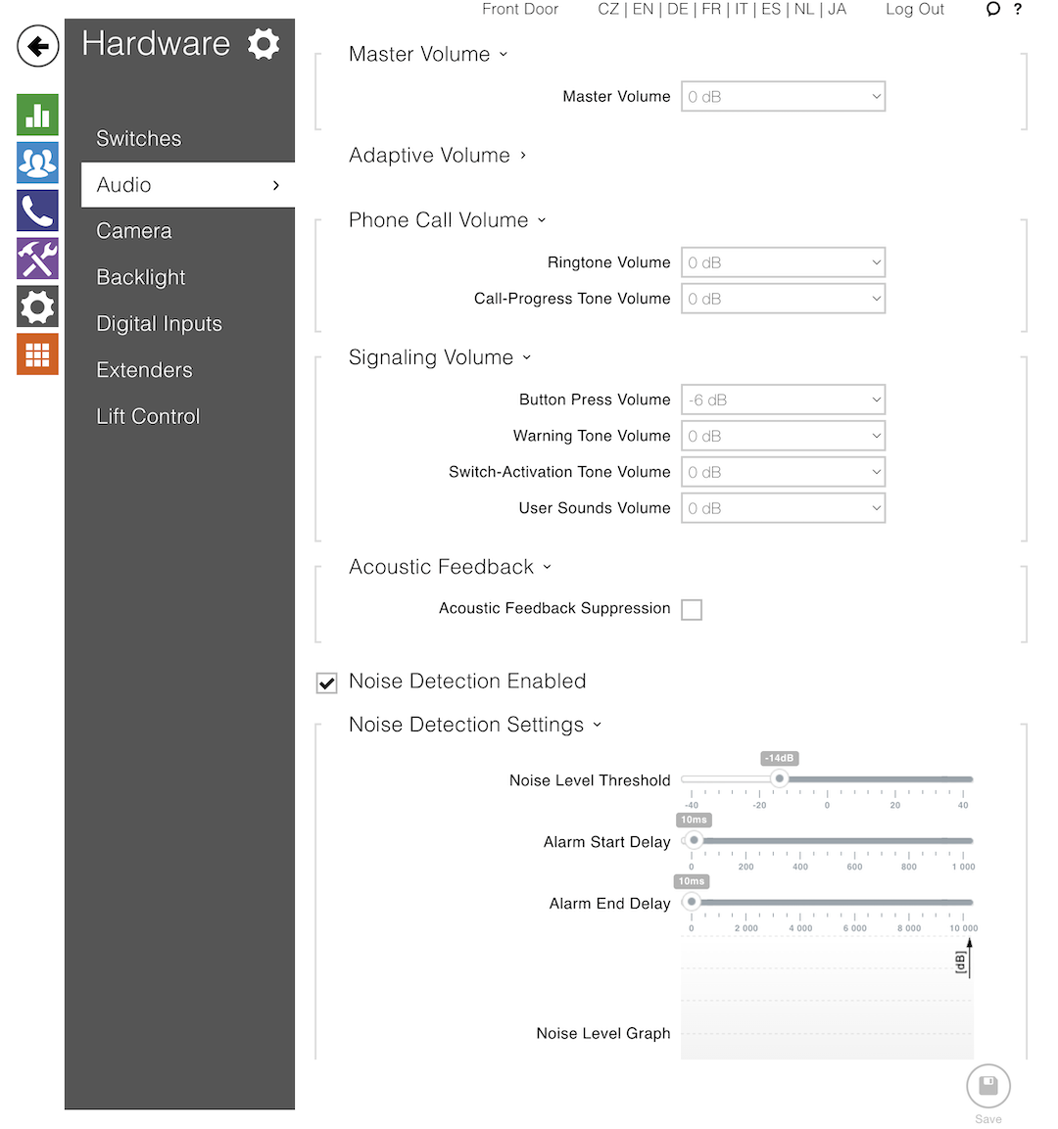
- Configuration changes aren’t persisting: Your 2N device is likely setup for Automatic configuration mode and you’re trying to configure it locally. See Local vs Remote Configuration section for details.
- Josh fails to accept incoming call from 2N:
  - If your 2N is set to call other devices on button press, see Incoming calling (2N to Josh)
  - Make sure the Phonebook entry for the Josh system has the correct IP address
  - Make sure the 2N SIP account is using port 5060 and has an empty Phone Number (ID)

Other useful settings and related information

Door Stations
Josh.ai natively supports door stations through all Josh Apps, Josh Touchscreen, and our natural voice commands.

Video Streaming
Josh supports the full frame-rate H.264 video stream via RTSP. This can be viewed whether you are on the same network as Josh, or via the internet off-network.

Doorbell Press Announcement
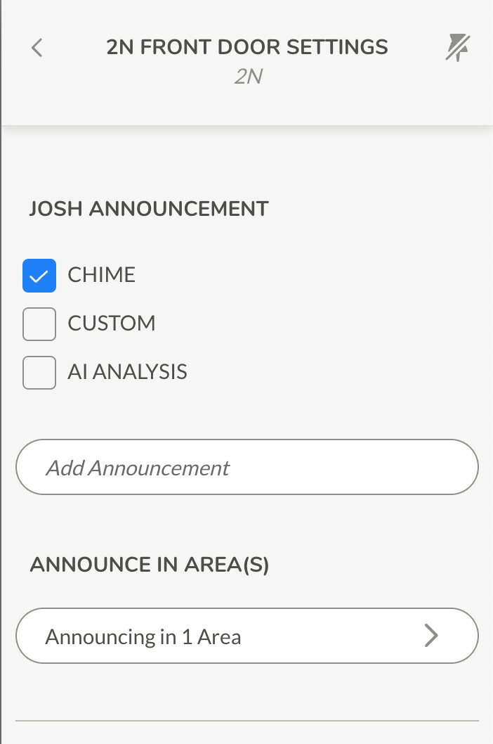
When the Doorbell button is pressed, Josh can make a variety of announcements that play through your home’s sound system.
Chime
Play a built-in doorbell chime sound.

Custom
Play custom text. The syntax is the same for scene responses.
AI Analysis
Play an AI analysis of what is currently in the video stream. An example analysis is I see a delivery person standing outdoors in a green environment, holding a cardboard package. The individual is wearing a yellow and red uniform, possibly representing a postal or courier service.
This is a great way to know who is at the door without needing to look at your phone or a Touchscreen.
Announce in Area(s)
Configure which Josh areas to play the announcements in. You can choose any combination of areas containing announceable audio devices.

Access Control/Relays
Most Door Stations have built-in relays. These can be wired to gates, door latches, porch lights, etc. Josh discovers these as Switches. You can then change the type to better model the physical device.

DoorLink
What is DoorLink?
DoorLink is the ability to call and answer your Door Station, in real time 2-way audio and streaming video. When the Doorbell button is pressed on a compatible Door Station, Touchscreens will indicate an incoming call, and mobile phones can receive push notifications. The user can accept or decline the call.
Josh Touchscreen Settings
By default, Josh Touchscreen will ring when the doorbell button is pressed. To configure the audio of the ring, on the Touchscreen, navigate to Settings > DoorLink Settings.
- Ring on Door Station Call: Whether to play a ringing sound while the Door Station call is incoming (i.e. for up to 30 seconds after pressing the doorbell button). When disabled, the Door Station will still pop-up on the Touchscreen, but no audio will be played.
- Ring Volume: The volume at which the ringing sound is played.
- Ring Audio: The ringtone to play.
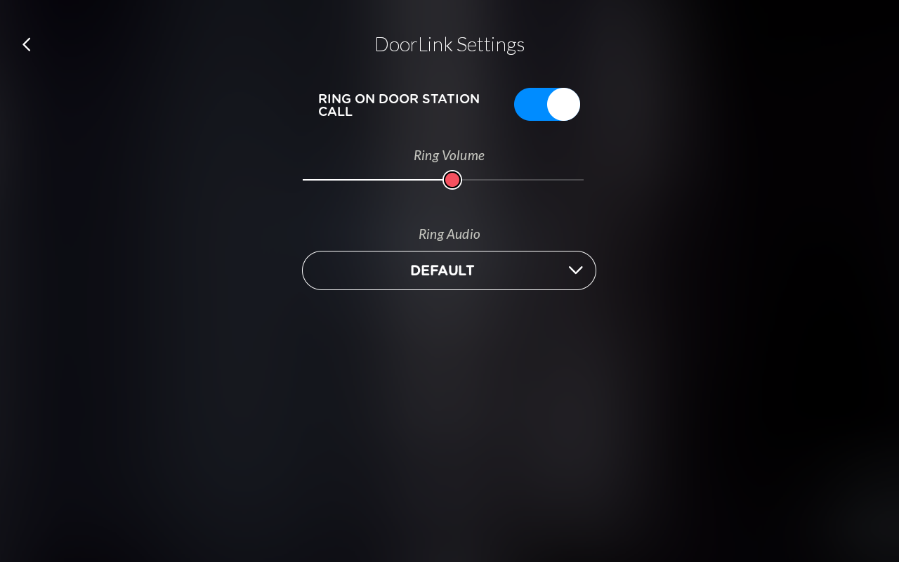

Notifications/Scene Triggers
Josh can send push notifications or trigger scenes on various events of the Door Station:
- Doorbell button press (with or without AI analysis of the video feed)
- Motion sensed
- Sound sensed (if hardware supports it)

